**Section 1: Acquiring Data**

**orders.csv – order_products.csv**

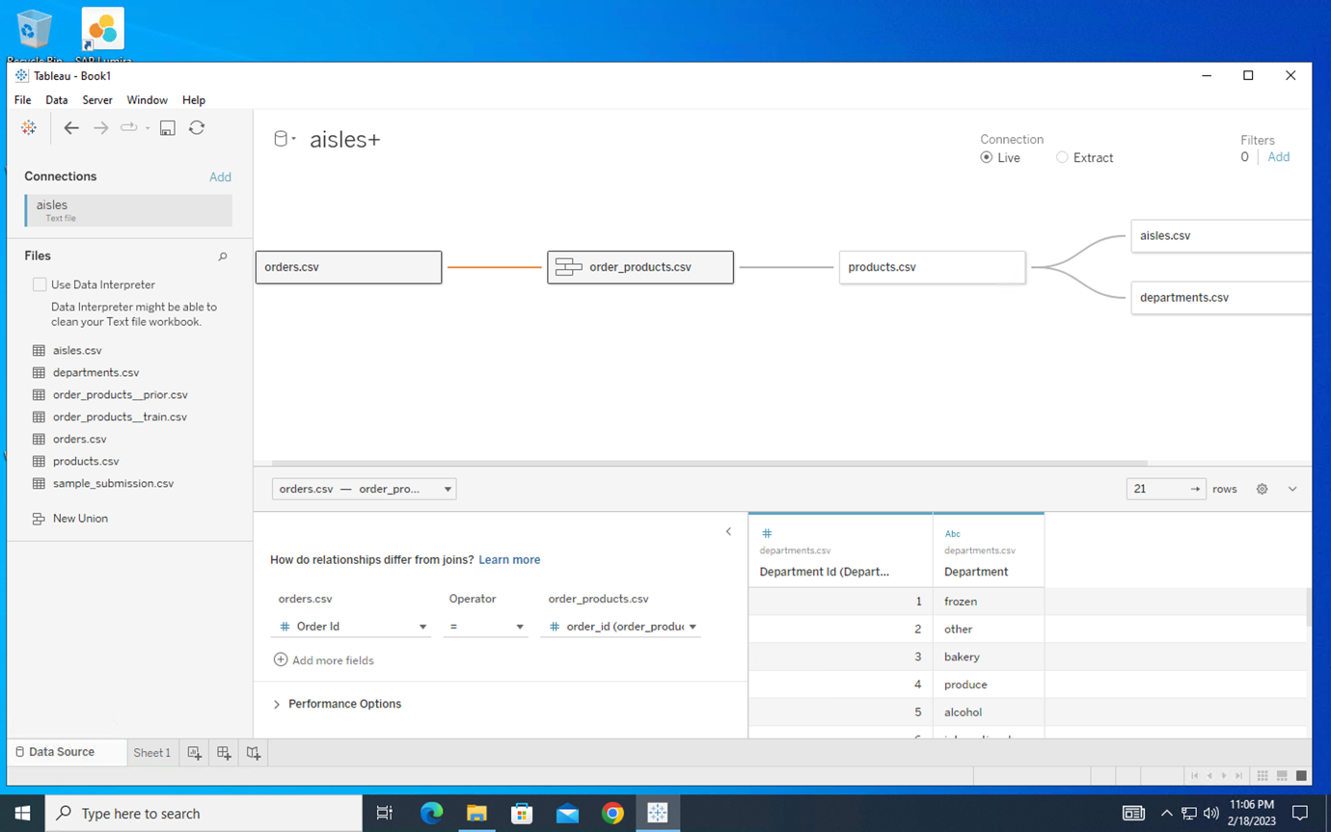

**order_products.csv – products.csv**

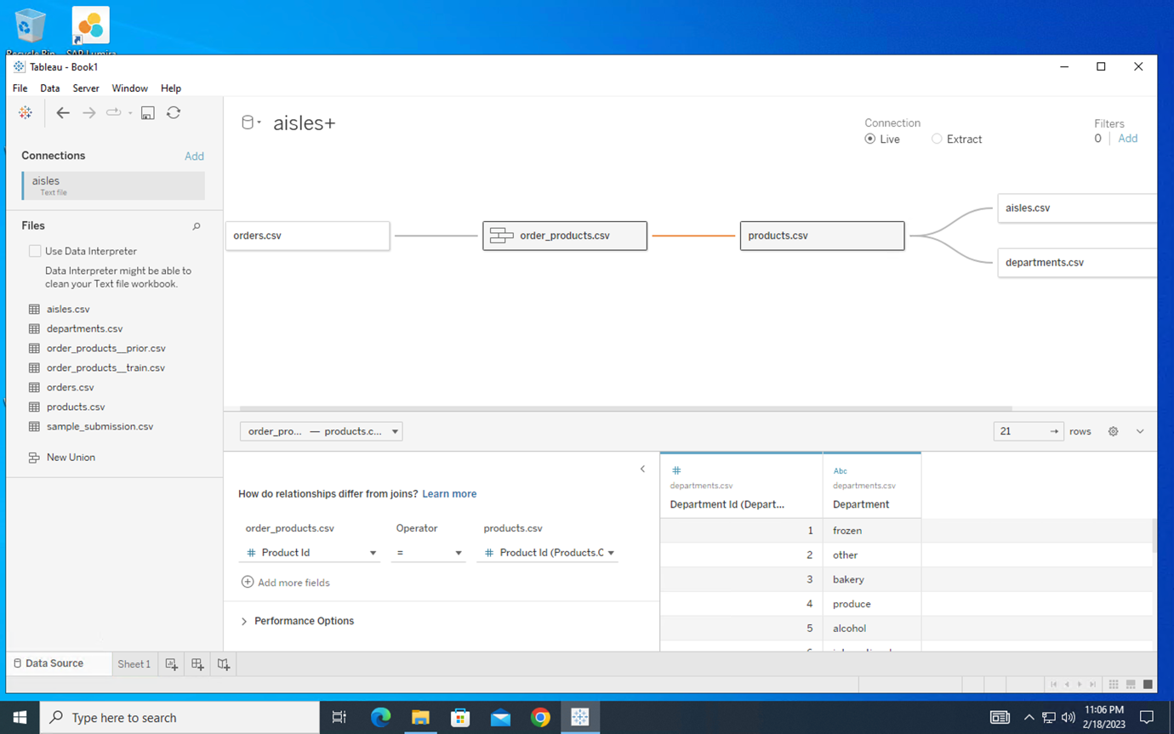

**products.csv – aisles.csv**

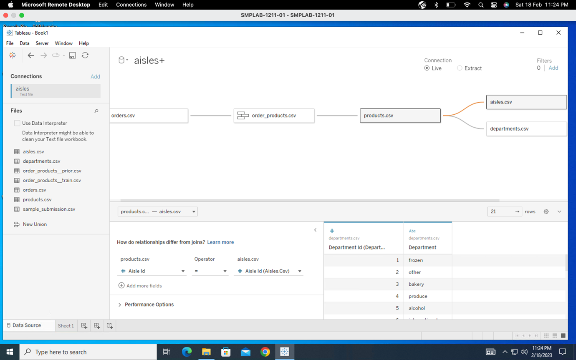

**products.csv – departments.csv**

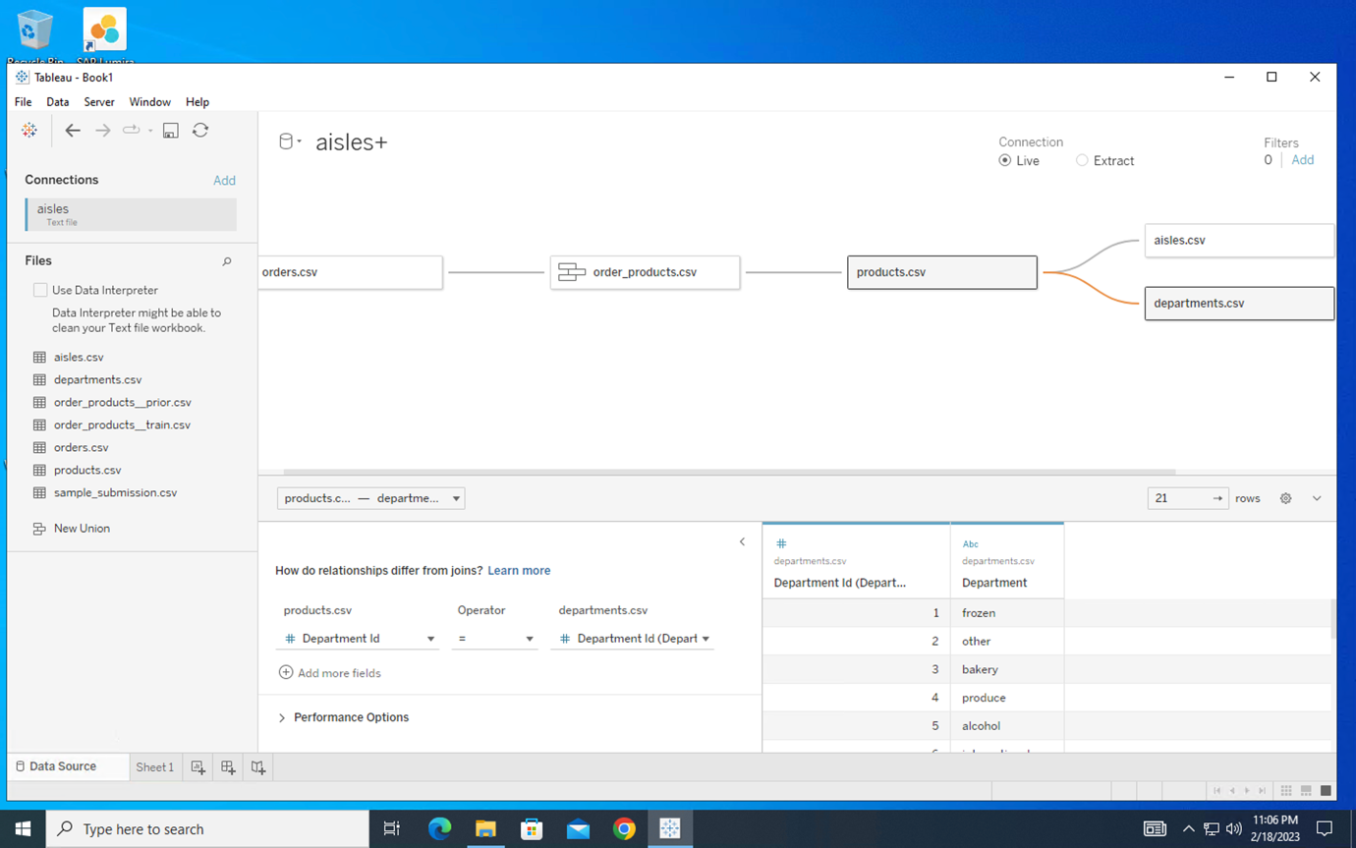

**Section 2: Defining the Audience**

1. The primary groups and individuals that are focus of our communication are:

* Senior leadership
* Buyers
* Merchandisers
* Marketing
* Store managers
* Sales associates
* Customer service people
* Competitors
* Customers

1. The senior leadership team's leader is the key decision-maker in the room.
2. The members of our audience are experienced in working with this data as they handle these types of orders on a daily basis, and together they have processed over 3 million grocery orders.
3. Our audience's reach is comprehensive, as it encompasses all aspects of the grocery orders that are processed by Instacart.
4. Our audience is focused on increasing profits by reducing the time between grocery orders. They aim to achieve this by ensuring that specific products are available during the hours and days when there is high demand for them.
5. To increase profits, our audience should prioritize improving the availability of products during specific hours and days when they are in high demand. This will help to reduce the time between grocery orders and ultimately lead to increased profits.
6. The satisfaction of customers and the availability of products are crucial factors at play here. By increasing the availability of products based on demand, more orders can be generated, resulting in reduced time between orders and increased profits. This, in turn, can lead to a more content senior management team, better employee reviews, improved customer service, and ultimately, happier customers.
7. The main idea is to invest in increasing product inventory, store staff, and the delivery team to fulfil the increasing number of orders. This would help to reduce the time between grocery orders, leading to an increase in revenue for Instacart.

**Section 3: Data Analysis**

**1. Service Analysis**

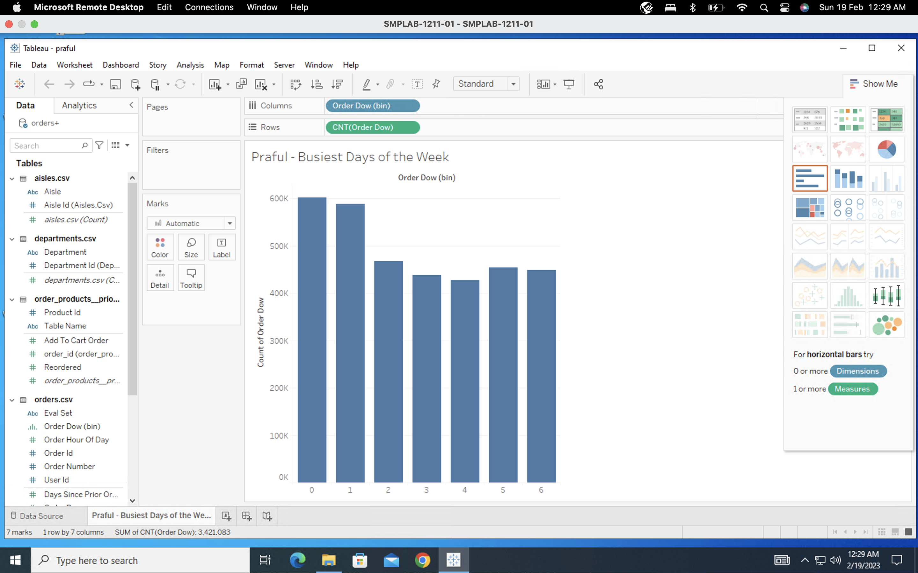

**Question 1**

The two busiest days of the week are day 0 and day 1 which correspond to Saturday and Sunday respectively.

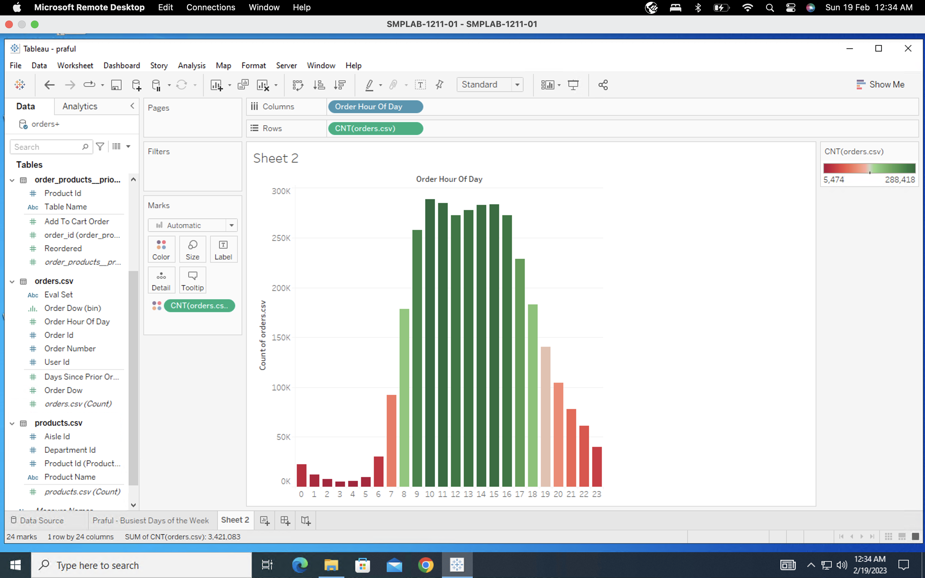

**Question 2**

The top 11 busiest hours are as follows:

1. Hour 10
2. Hour 11
3. Hour 15
4. Hour 14
5. Hour 13
6. Hour 12
7. Hour 16
8. Hour 9
9. Hour 17
10. Hour 18
11. Hour 8

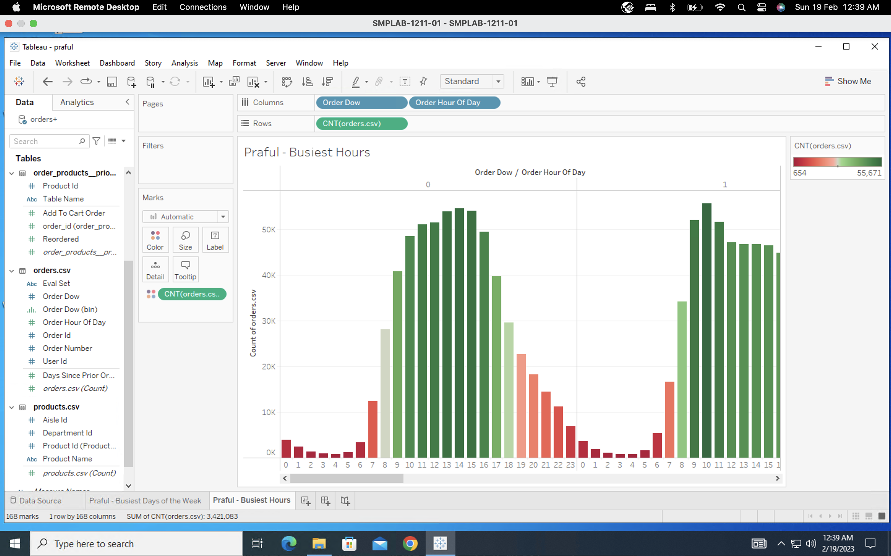

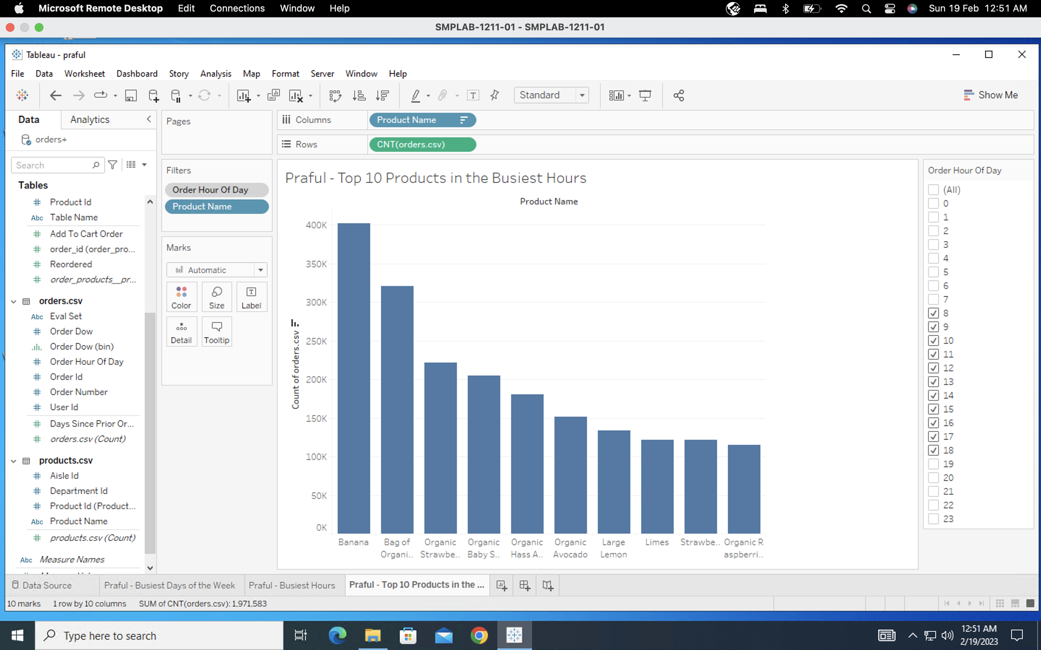

**Question 3**

**Banana** is the product that is sold most often during the busiest hours.

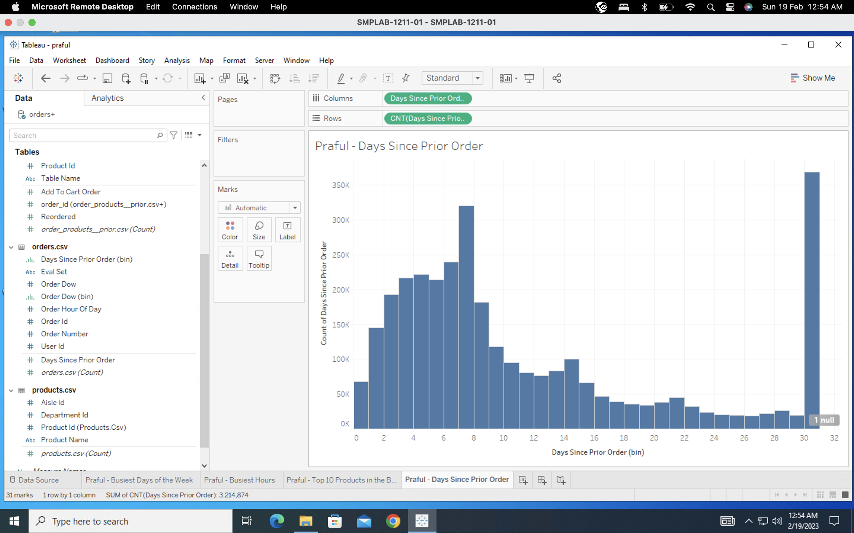

**Question 4**

Customers are most likely to order 30 days since prior order.

**2. Product Analysis**

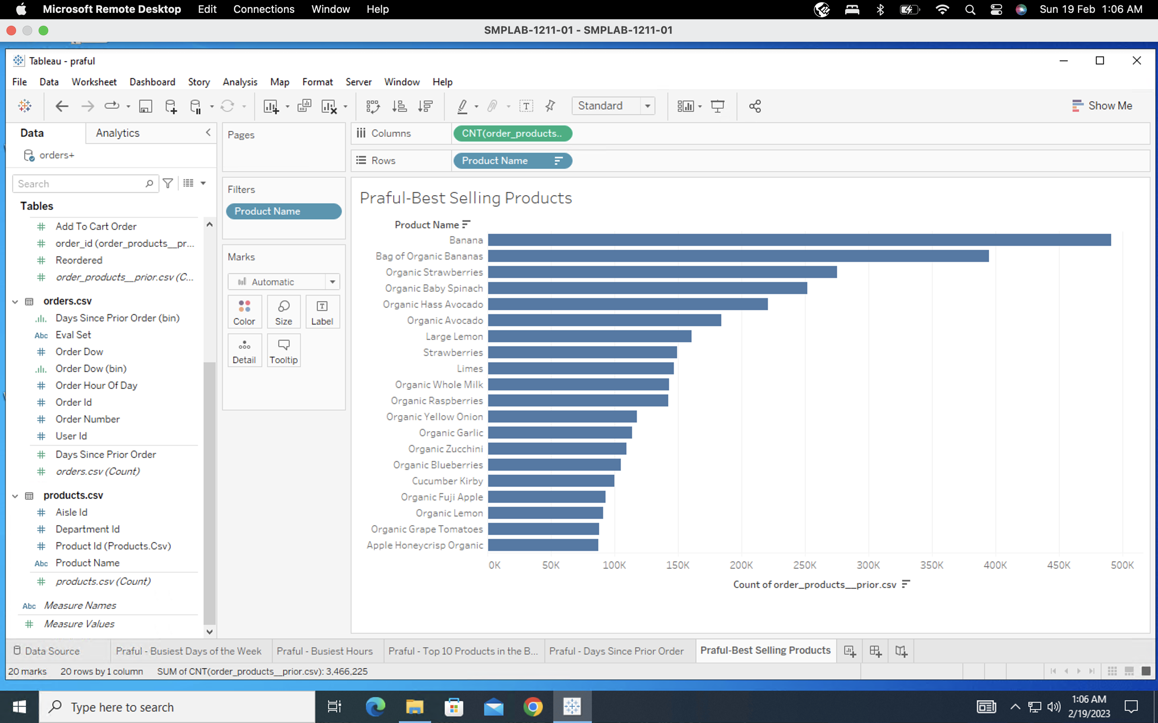

**Question 5**

The Top 3 best-selling products are as follows:

* Banana
* Bag of Organic Bananas
* Organic Strawberries

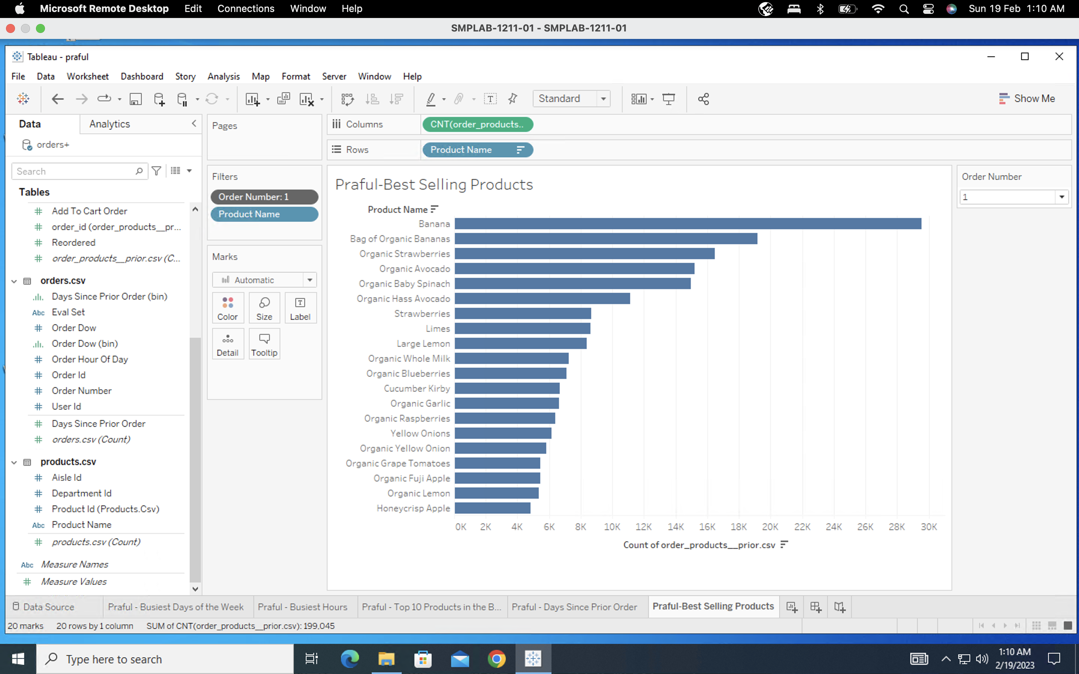

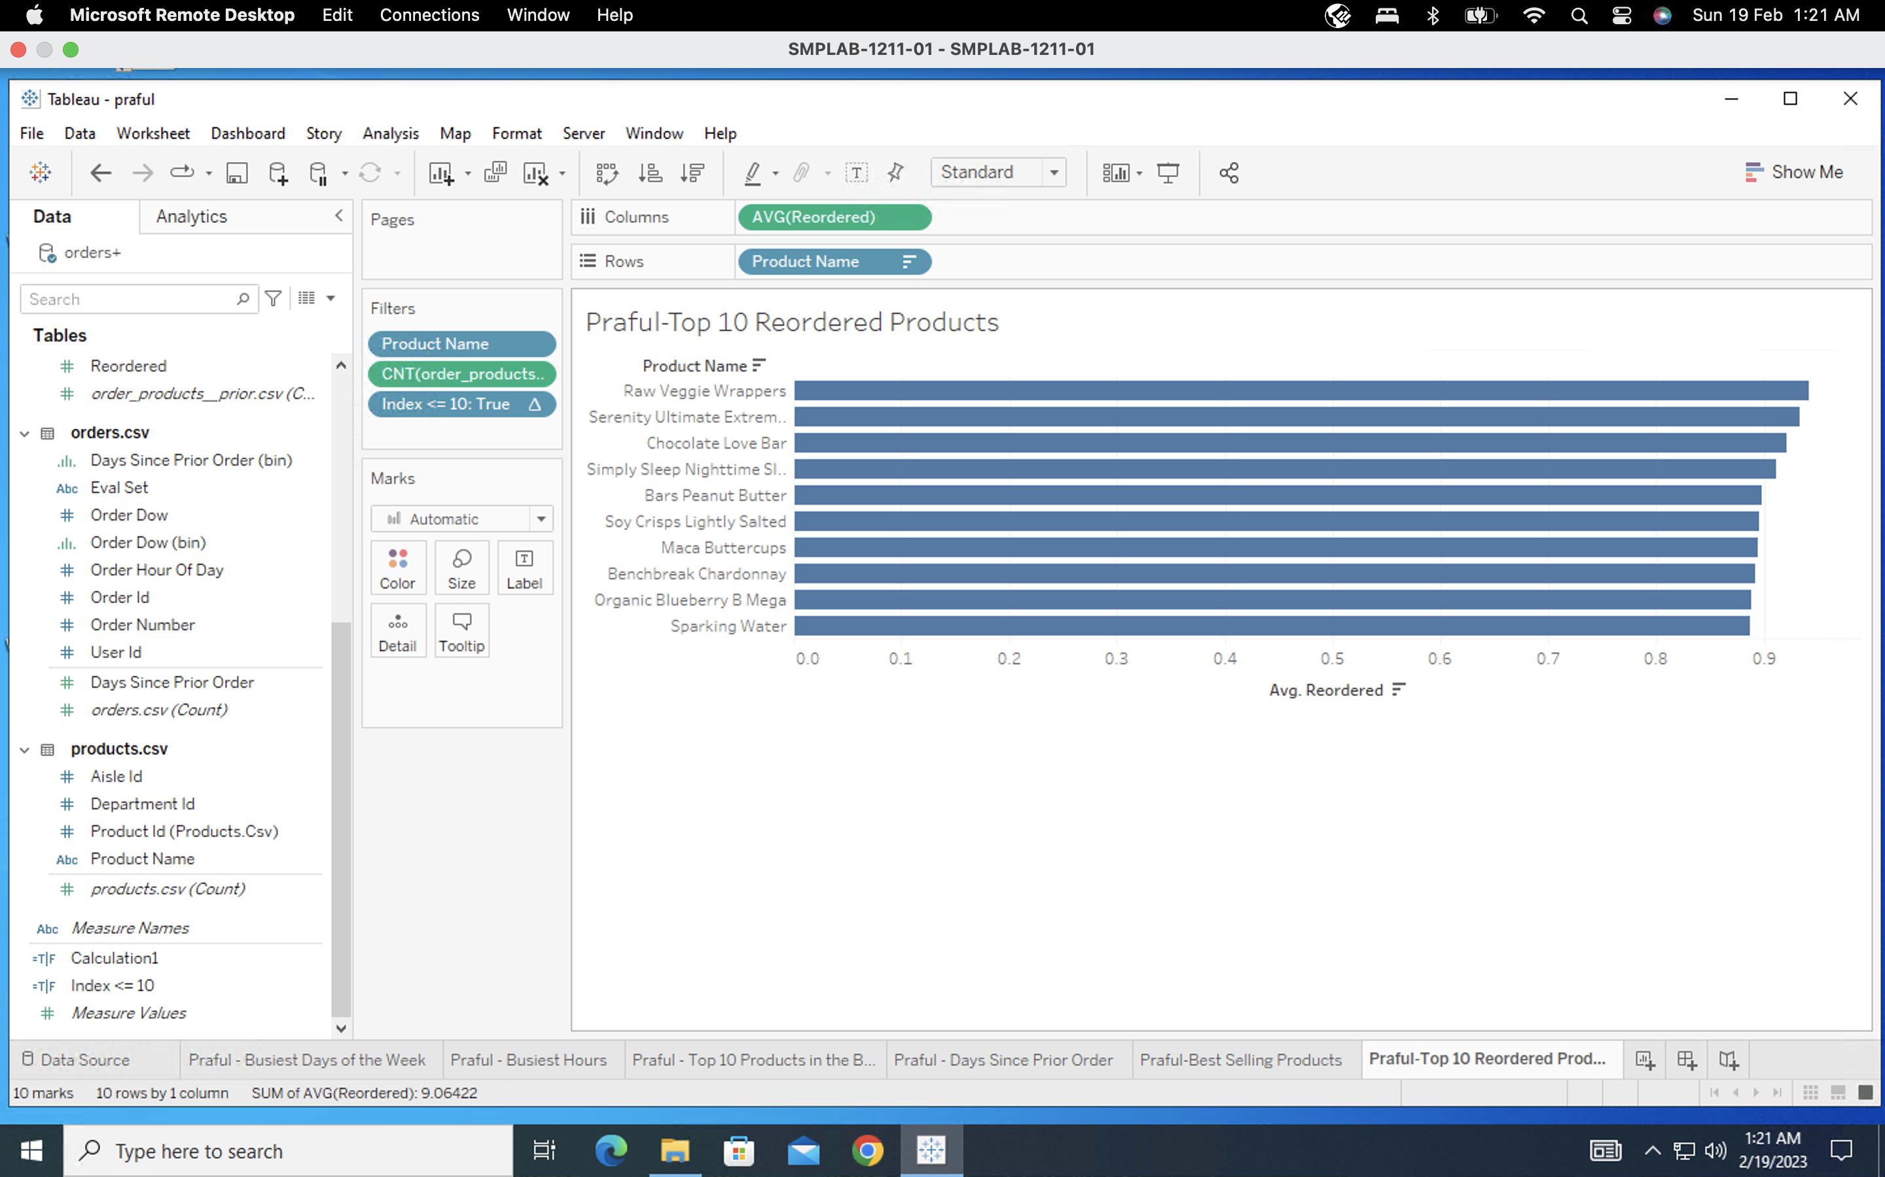

**Question 6**

The most reordered product is **Raw Veggie Wrappers** and the probability of being reordered is **0.94203**.

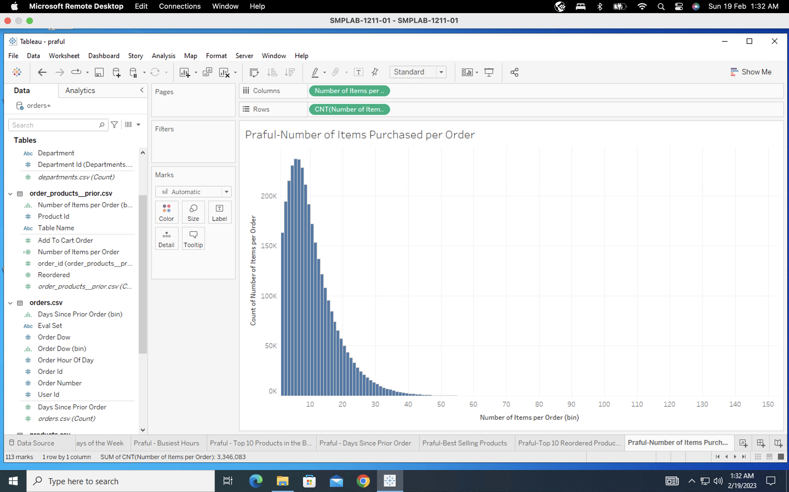

**Question 7**

Customers most often order **5** items.

**3. Category Analysis**

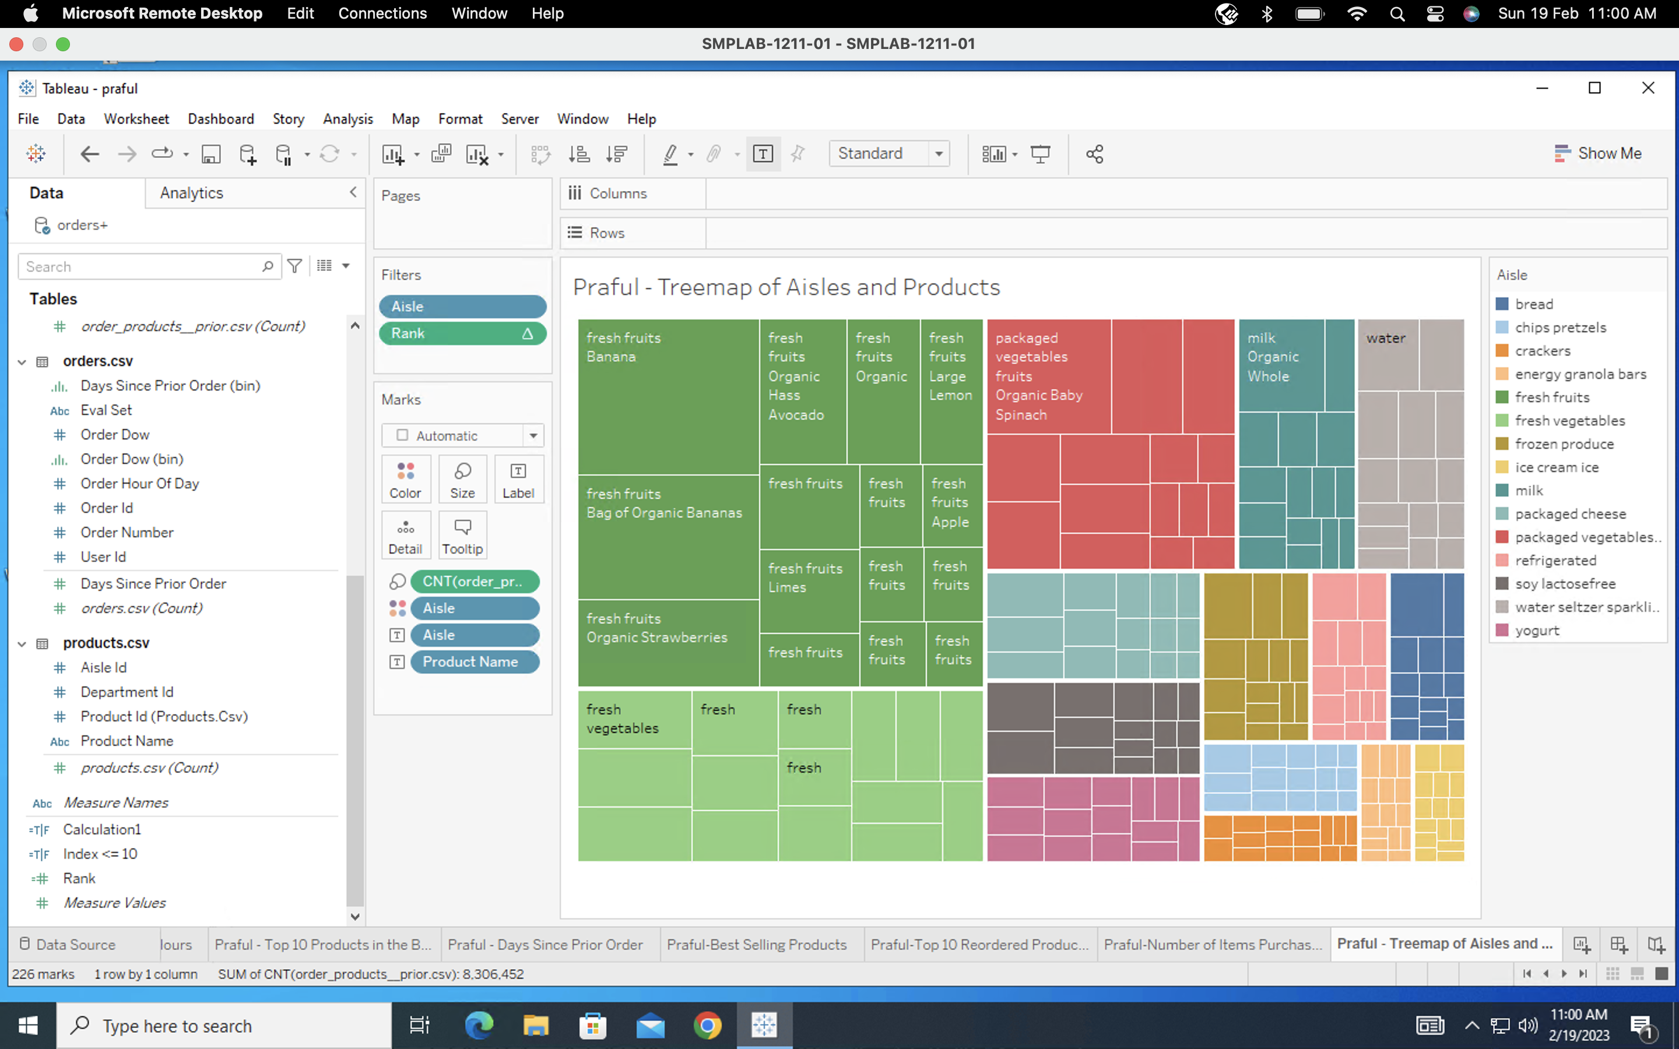

**Question 8**

The top 3 aisles that customers mostly order from are:

* Fresh Fruits
* Packaged Vegetables Fruits
* Fresh Vegetables

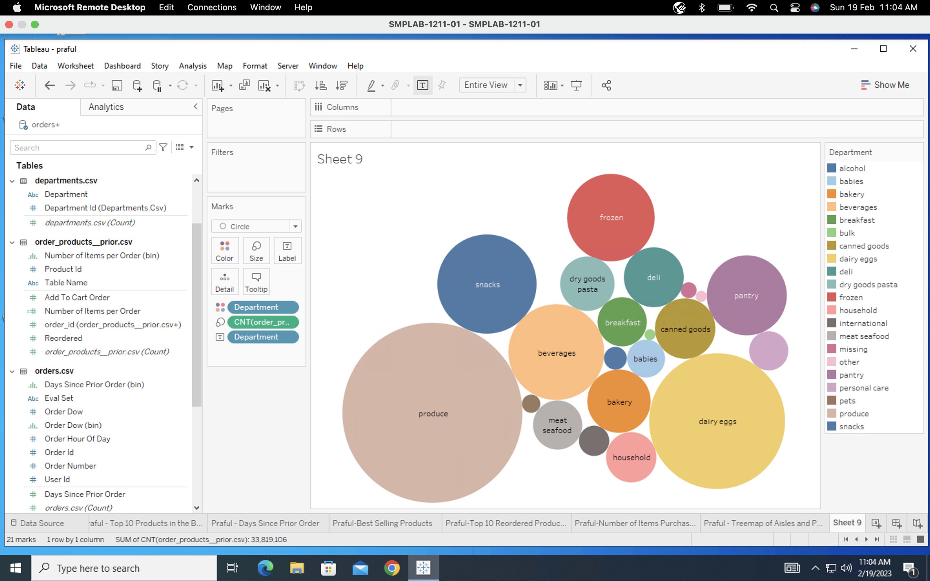

**Question 9**

The top 2 departments with the highest number of products sold are:

* Produce
* Dairy Eggs

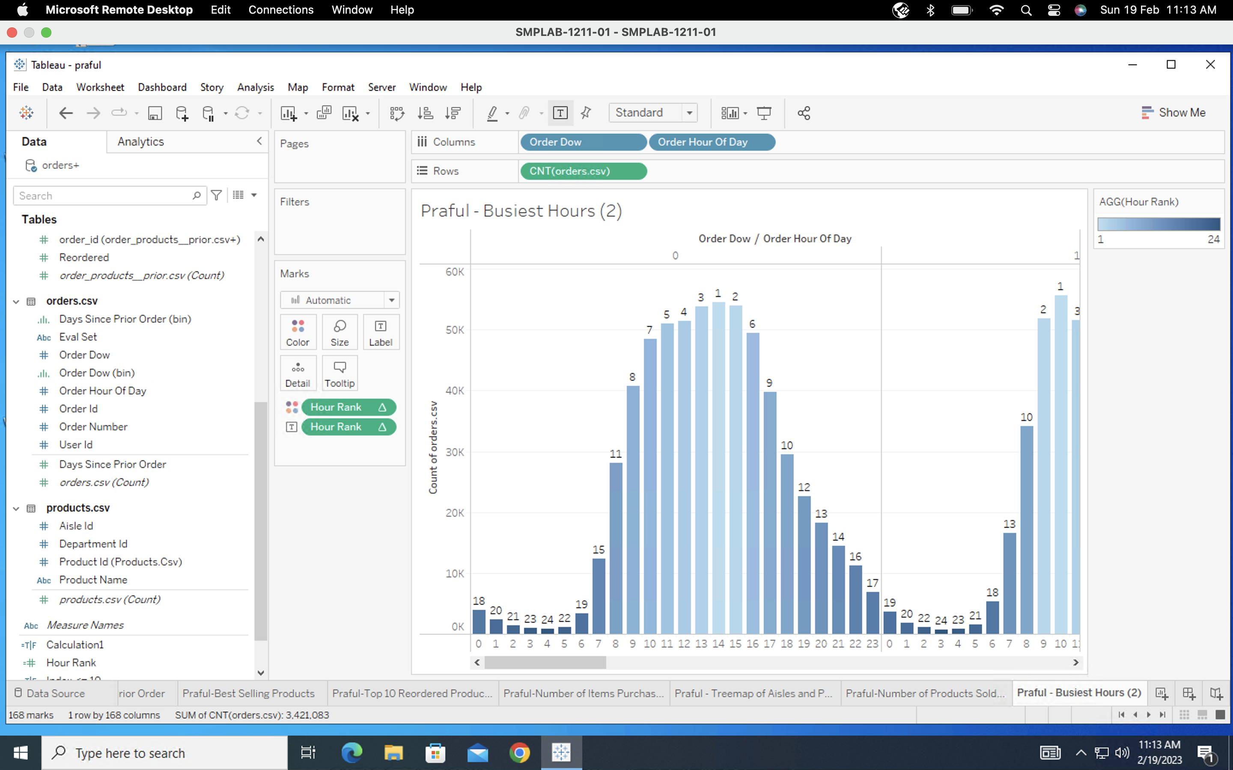

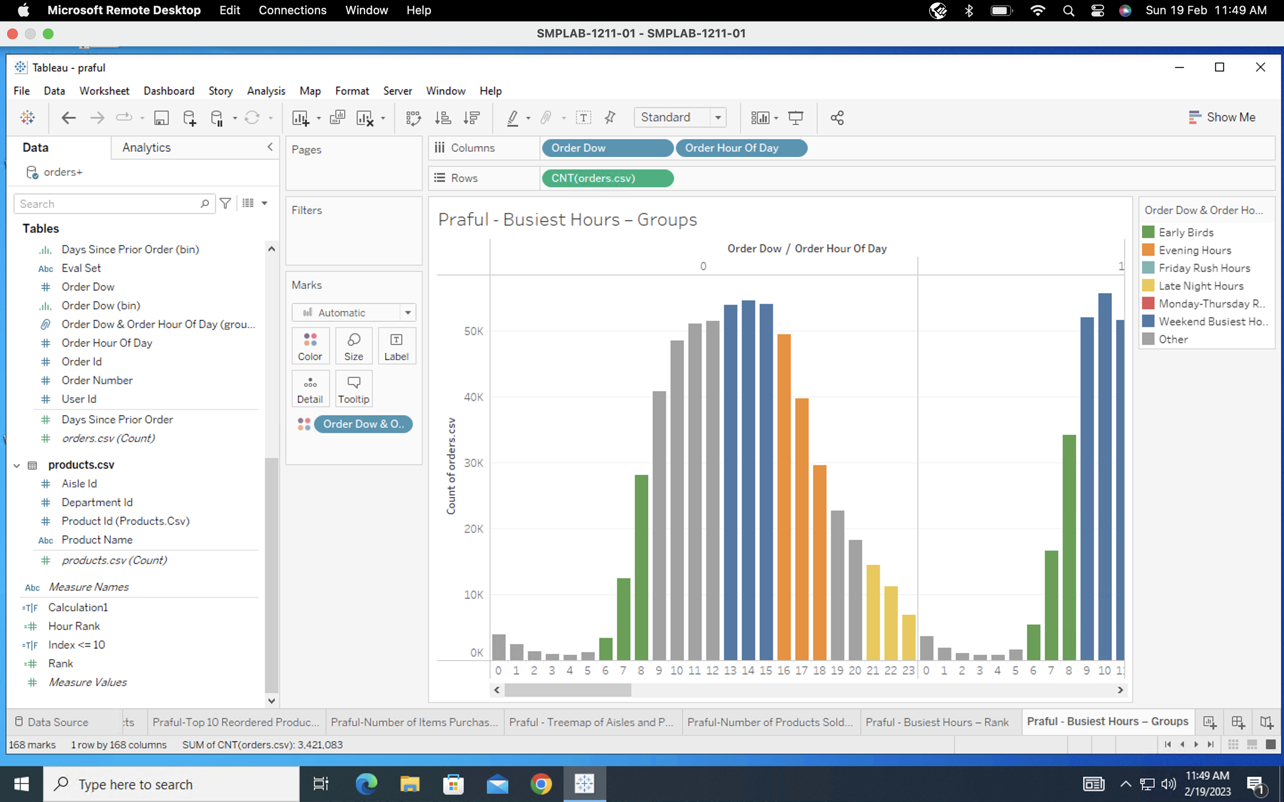

**Friday Rush Hours**

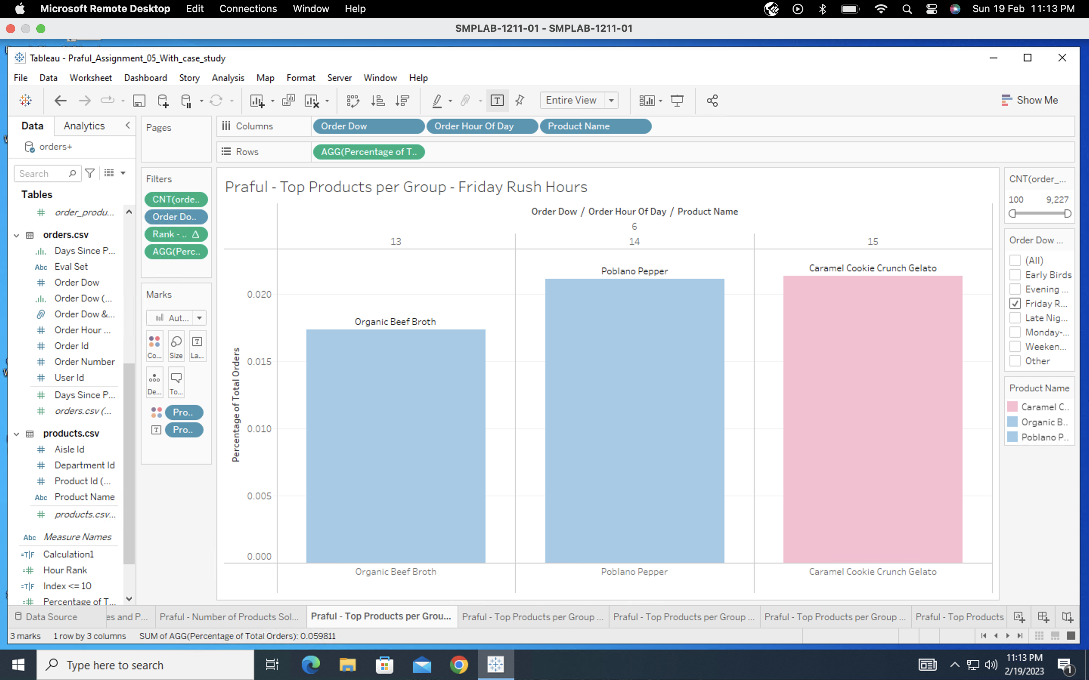

**Early Birds**

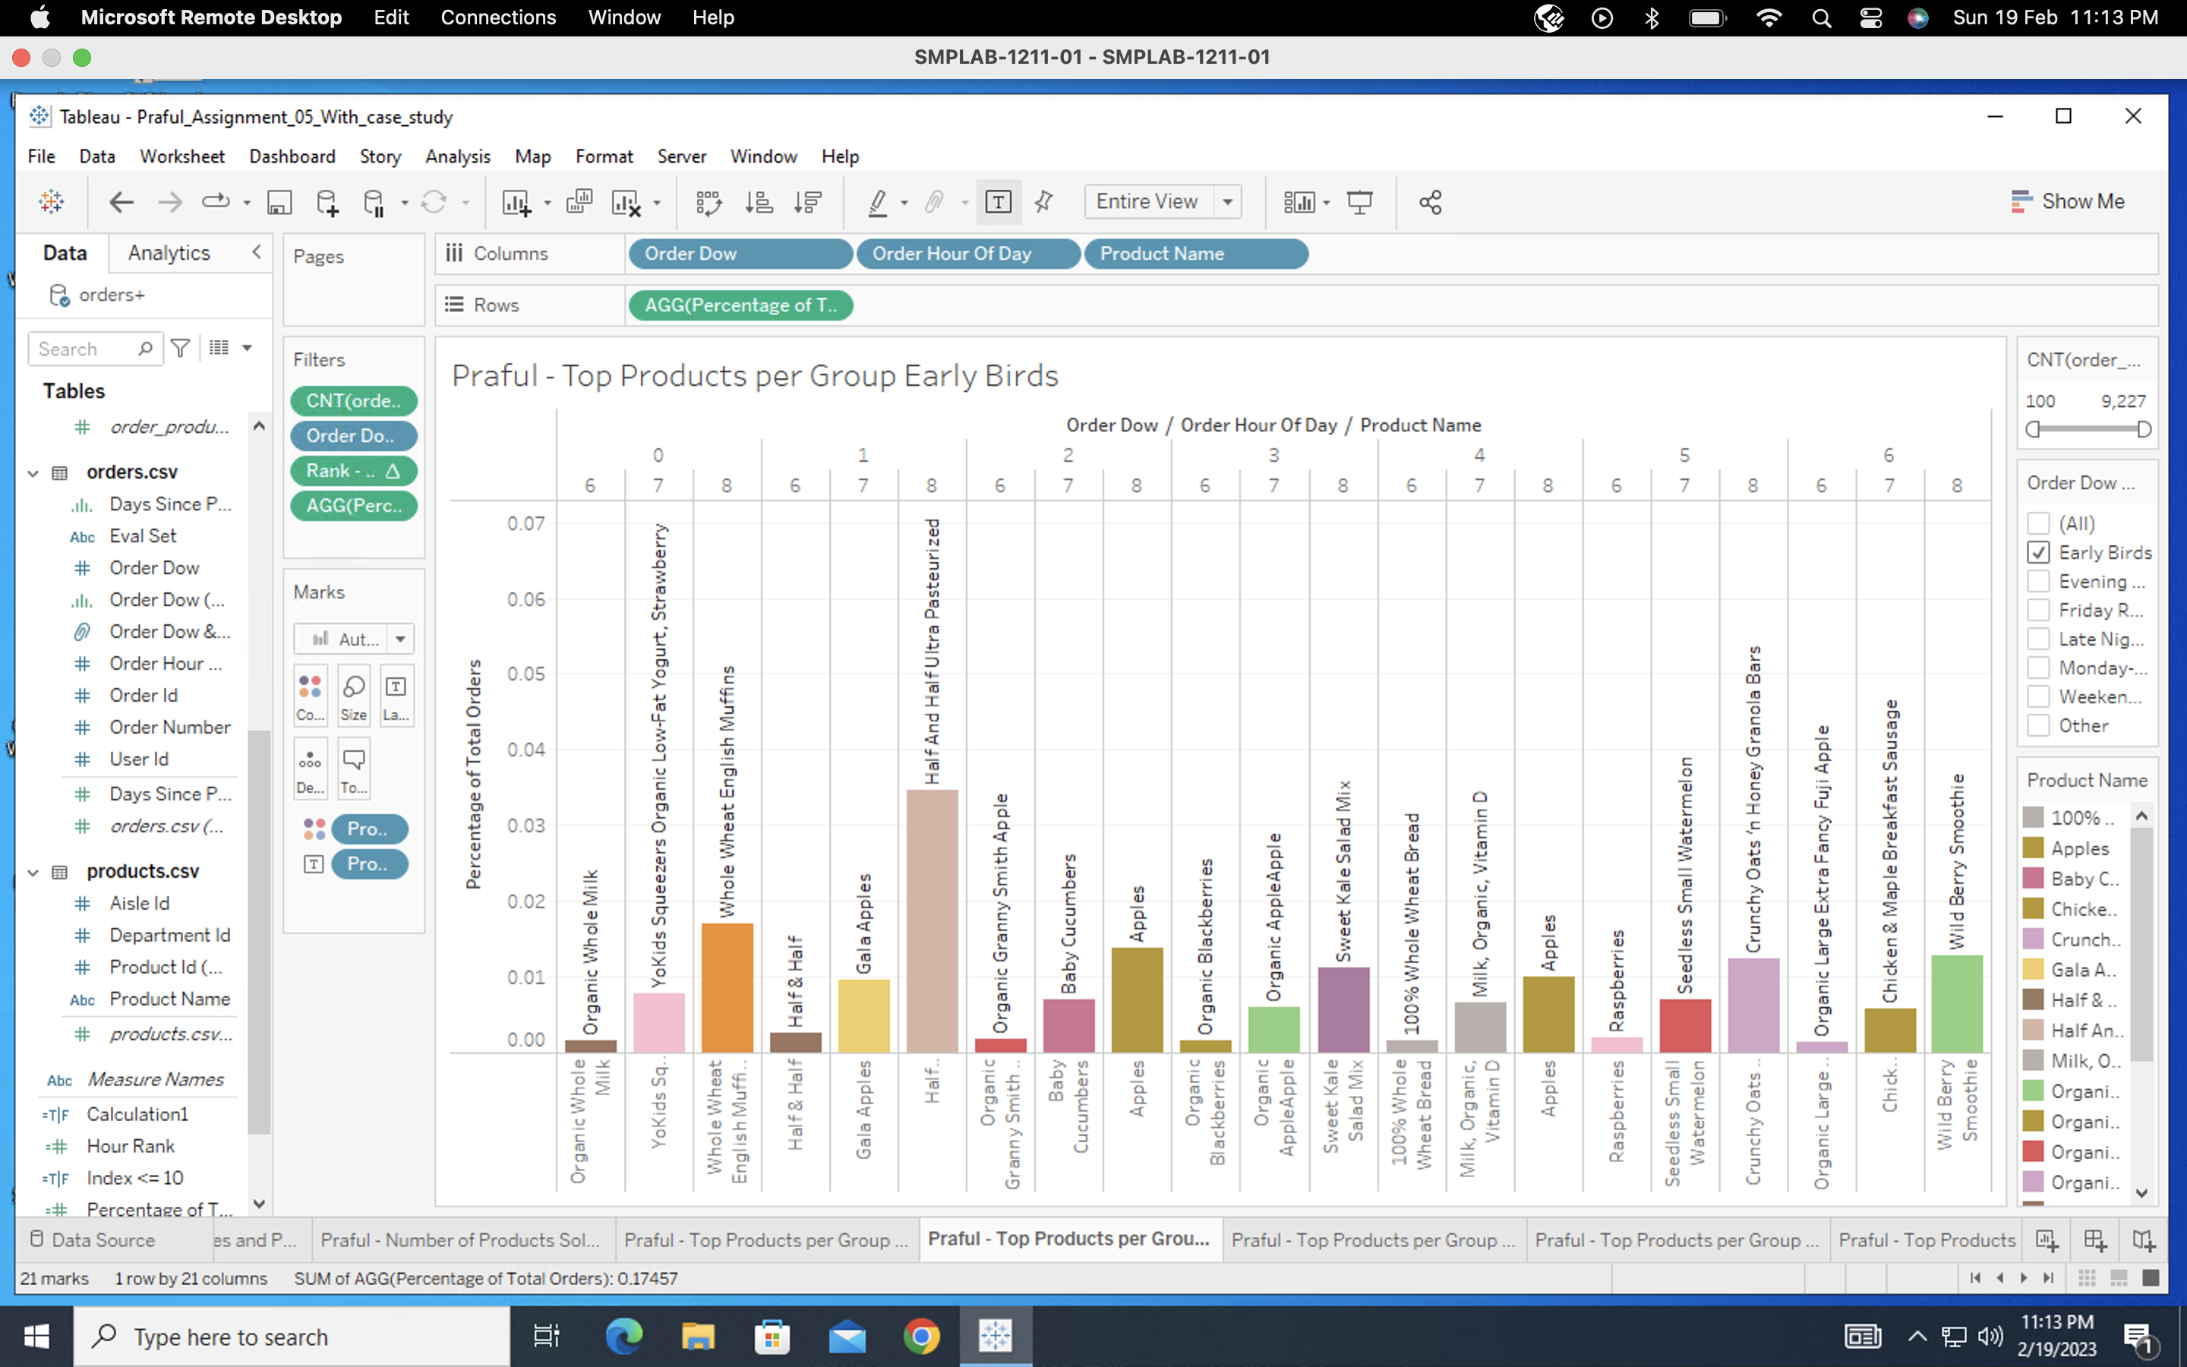

**Evening Hours**

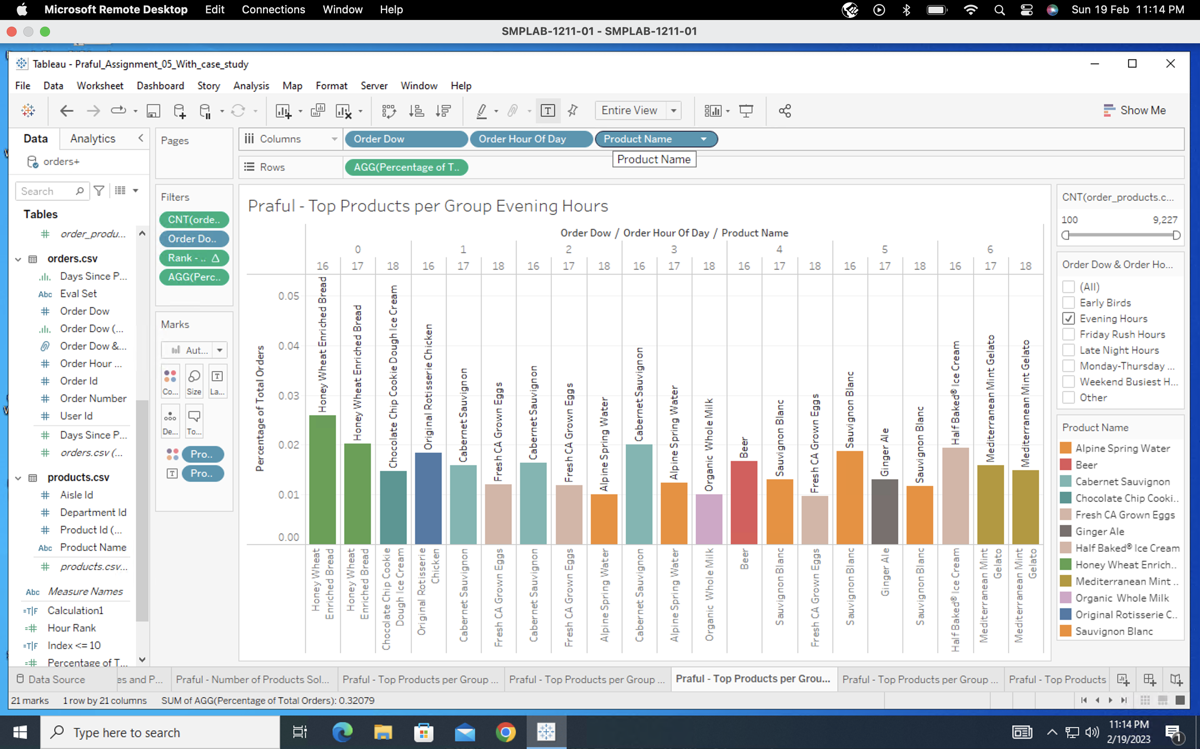

**Late Night Hours**

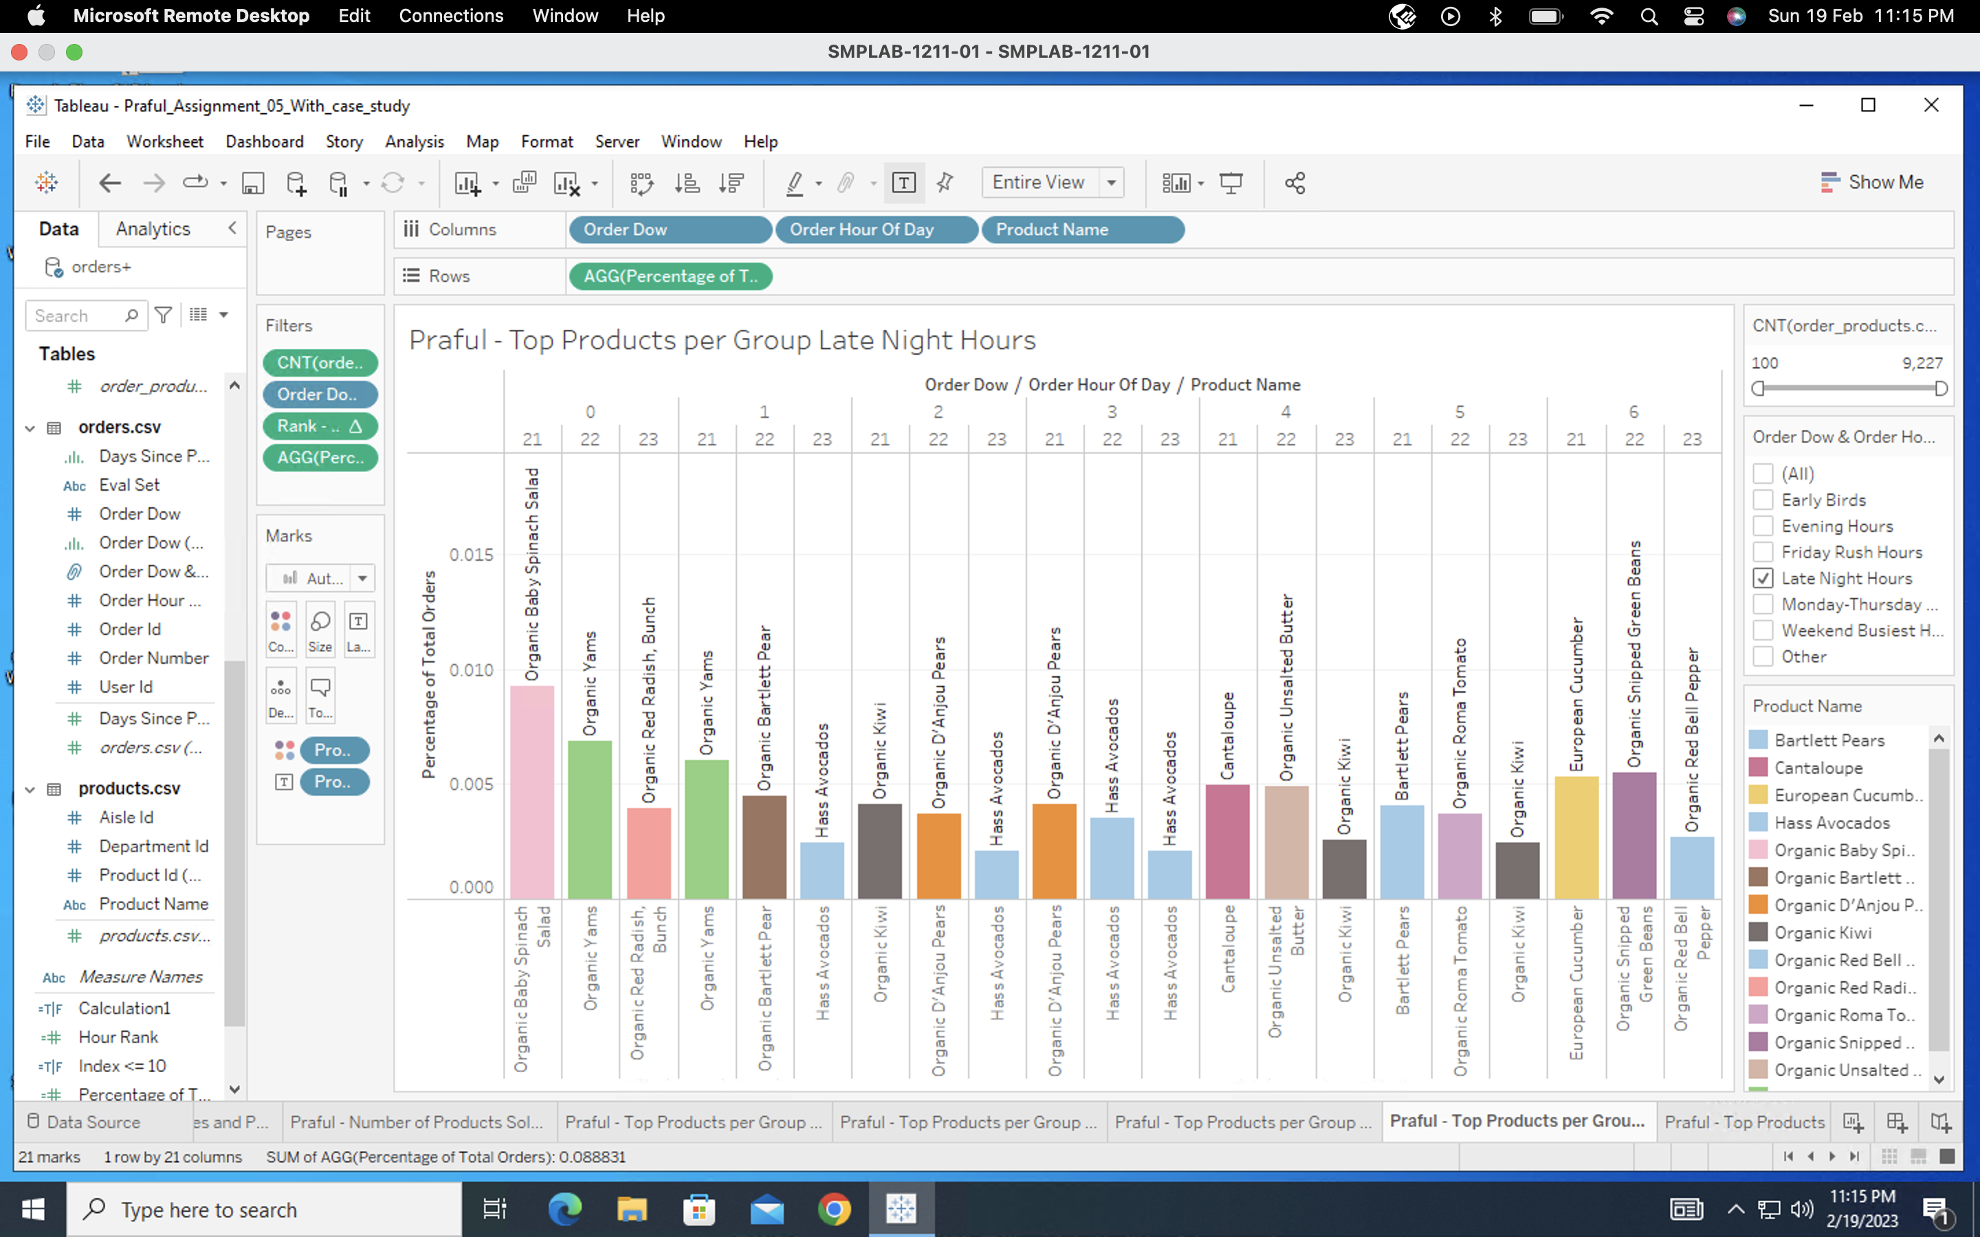

**Monday-Thursday Rush Hours**

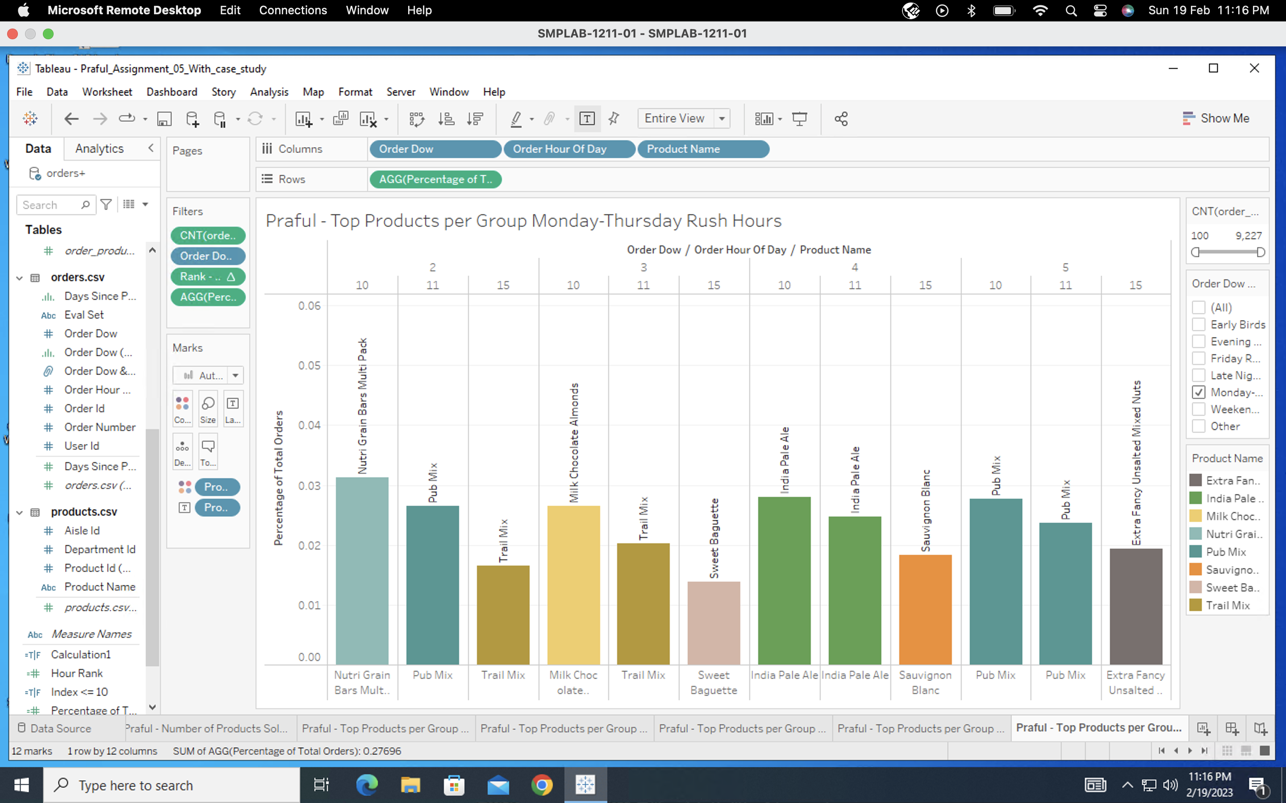

**Weekend Busiest Hours**

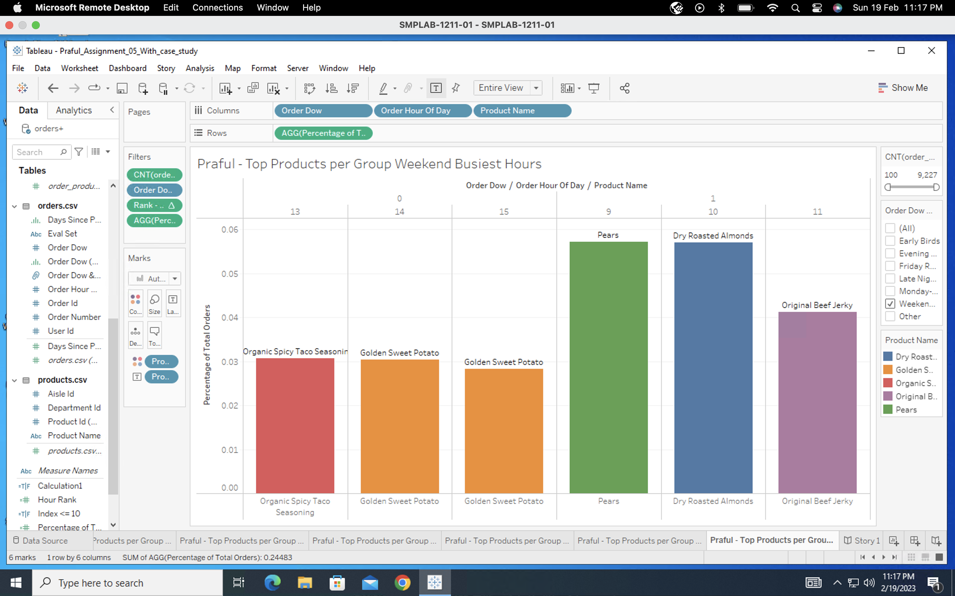

**Section 5: Organizing the Storyline with Storyboarding**

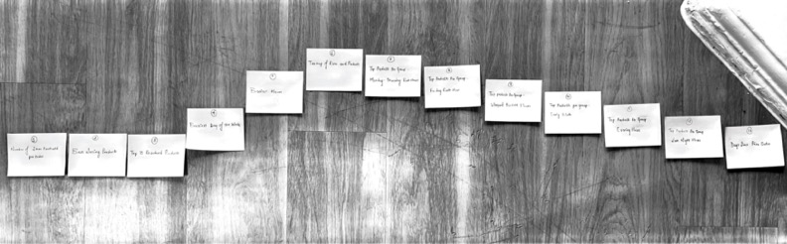

**Freytag’s Pyramid**

1. Number of Items Purchased per Order - **Beginning**
2. Best Selling Products – **Beginning**
3. Top 10 Reordered Products – **Beginning**
4. Busiest Days of the Week – **Rising Action**
5. Busiest Hours – **Rising Action**
6. Treemap of Aisles and Products – **Climax**
7. Top Products per Group – Monday-Thursday Rush Hours – **Falling Action**
8. Top Products per Group – Friday Rush Hours – **Falling Action**
9. Top Products per Group – Weekend Busiest Hours – **Falling Action**
10. Top Products per Group – Early Birds - **Falling Action**
11. Top Products per Group – Evening Hours - **Falling Action**
12. Top Products per Group – Late Night Hours – **Falling Action**
13. Days Since Prior Order – **End**

**Section 6: Adding Rhetoric to Your Story**

The use of **Logical Rhetoric** is the most effective approach for this story.

Screenshots of all of the Captions with visual in my Story are below: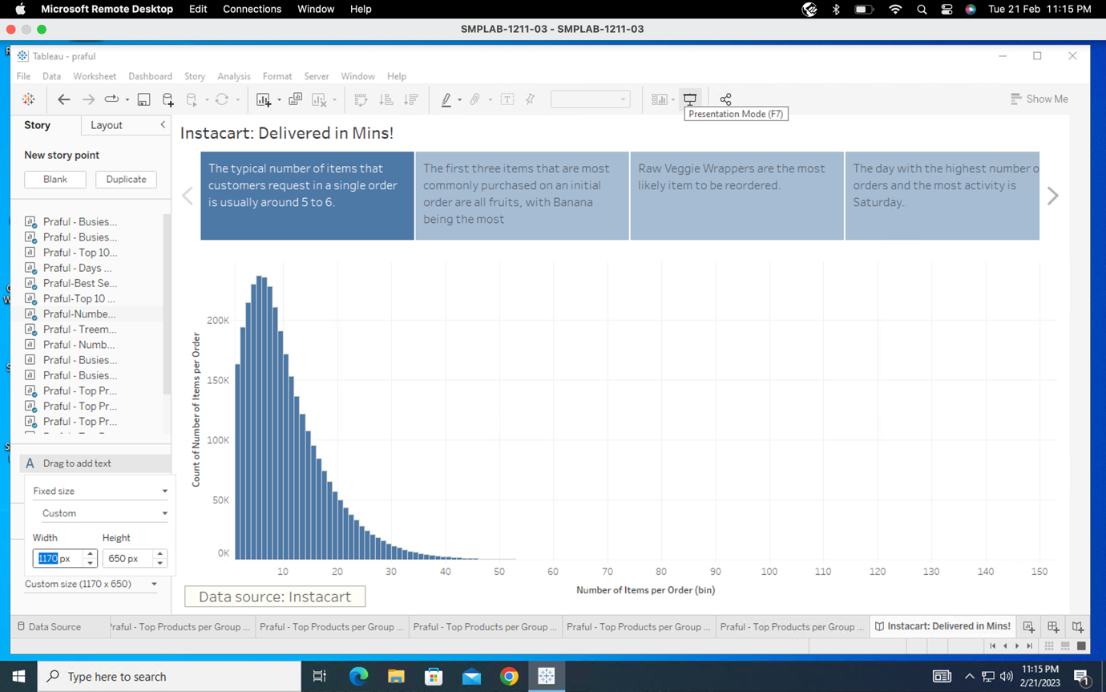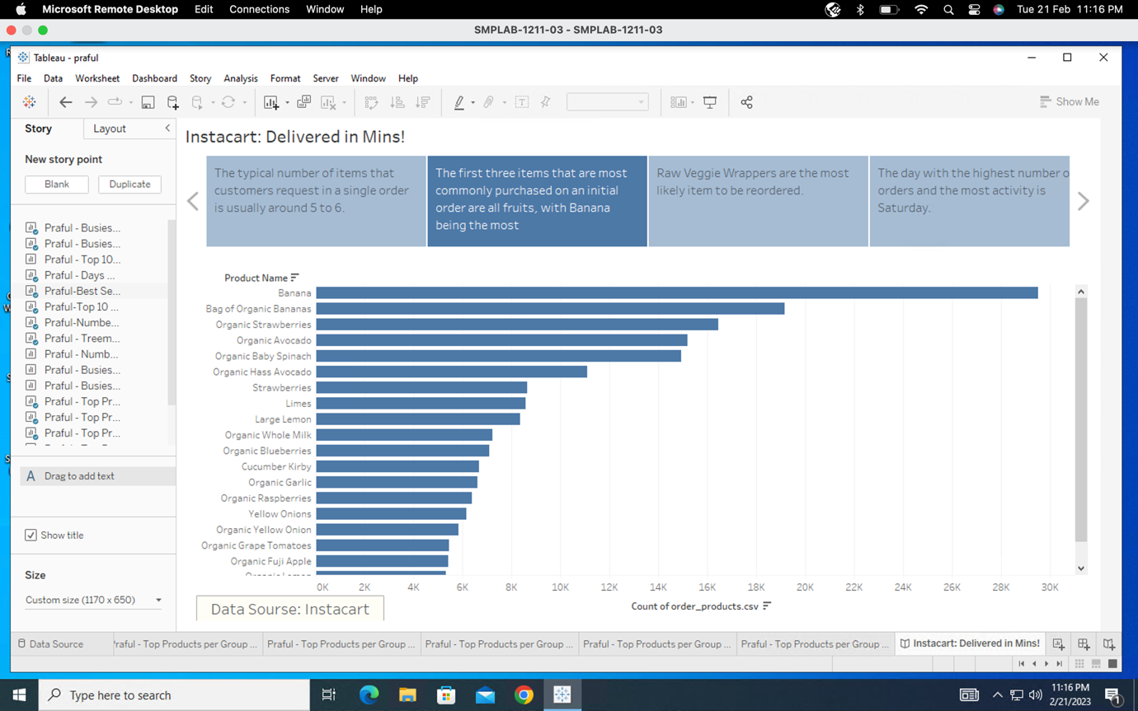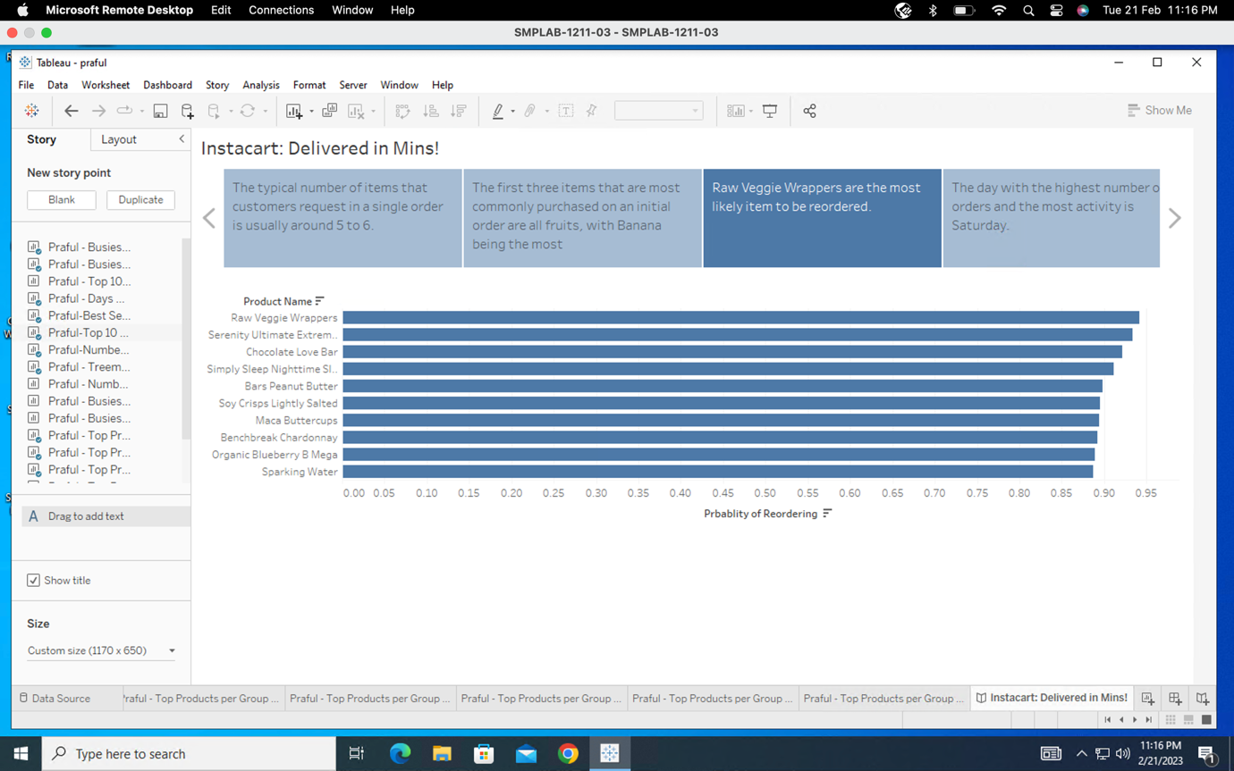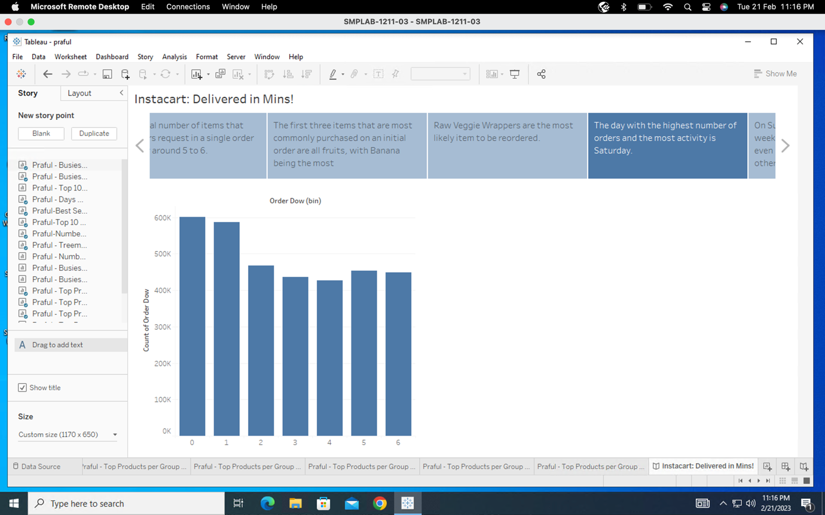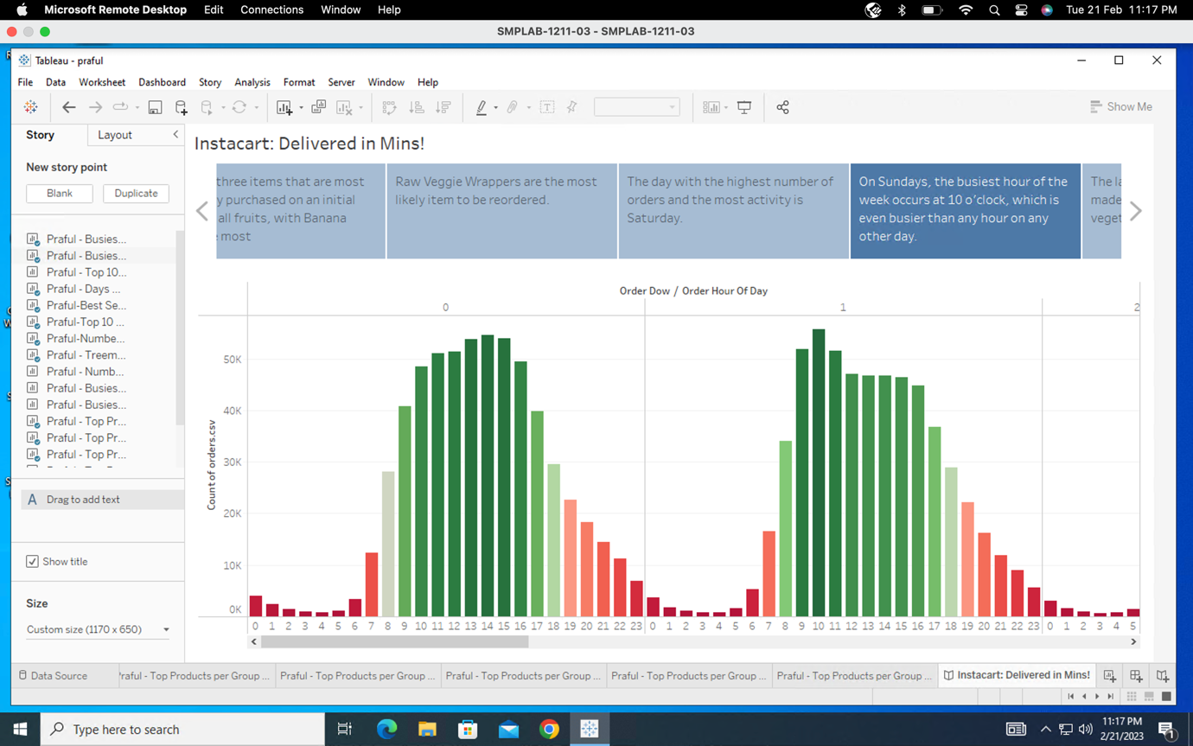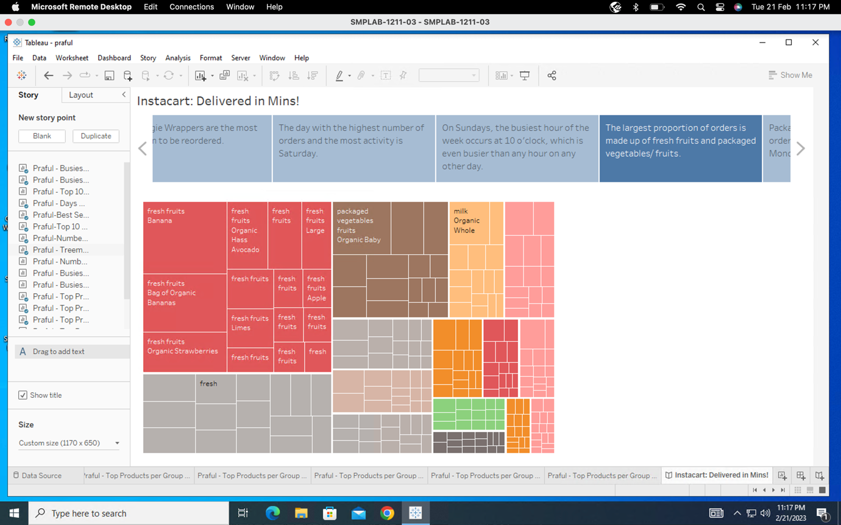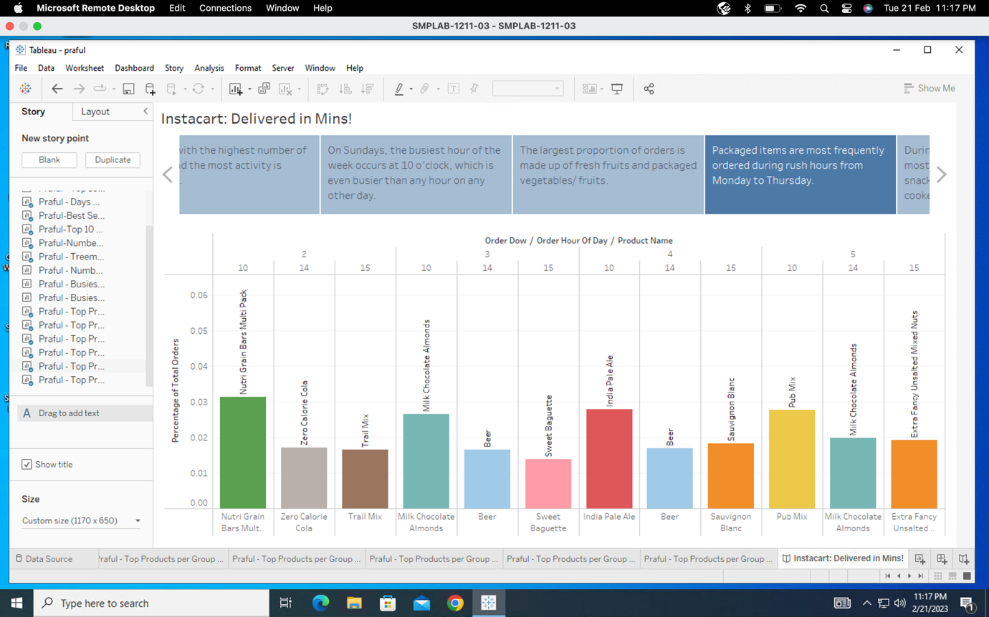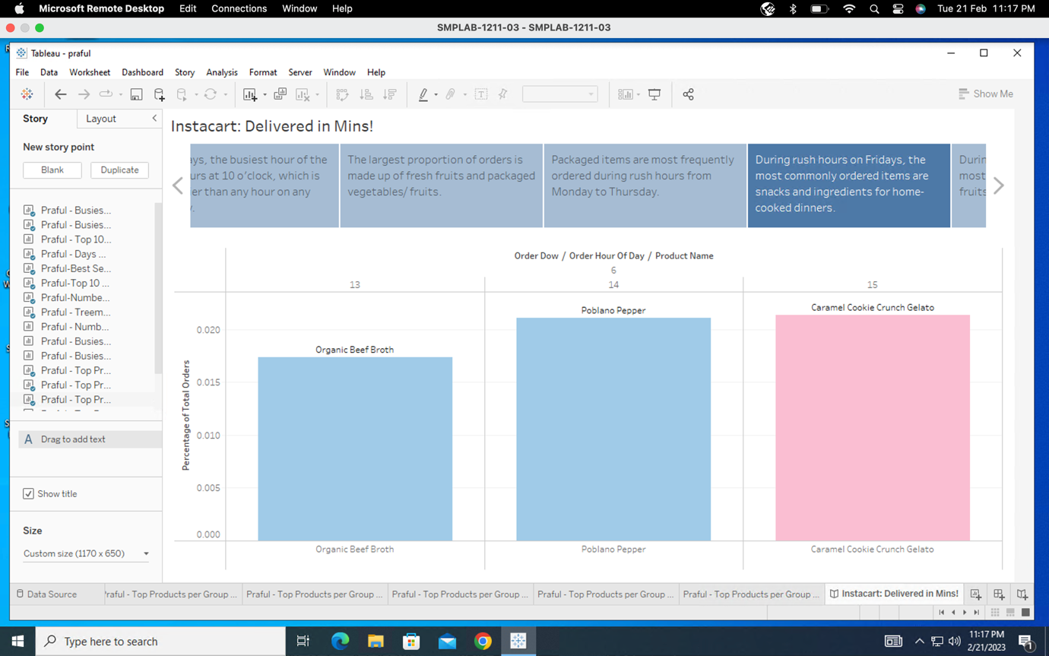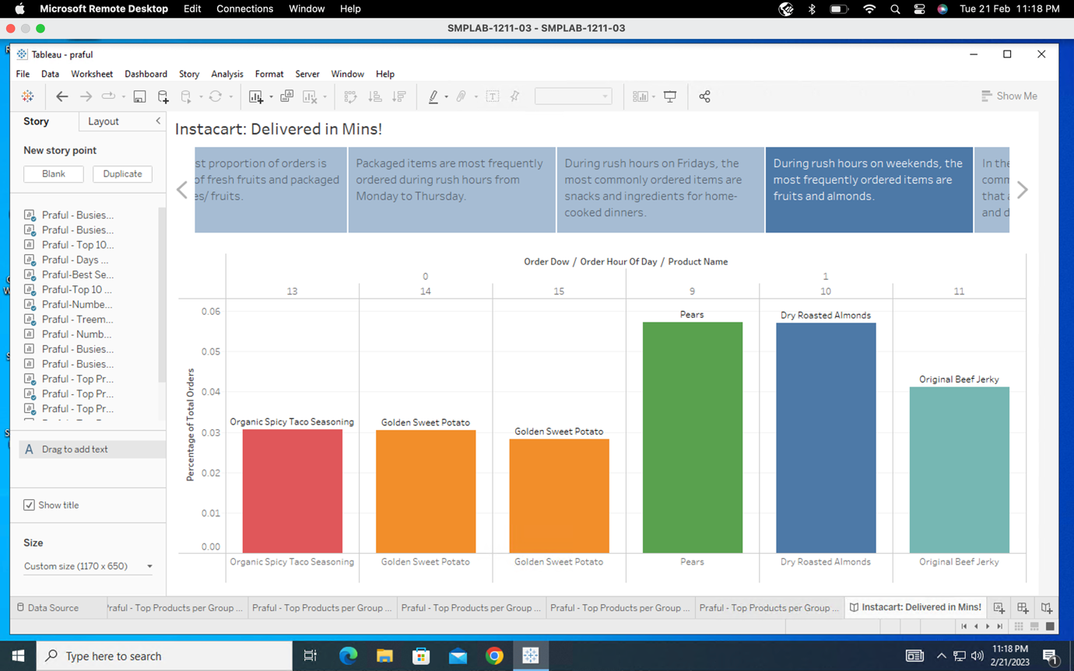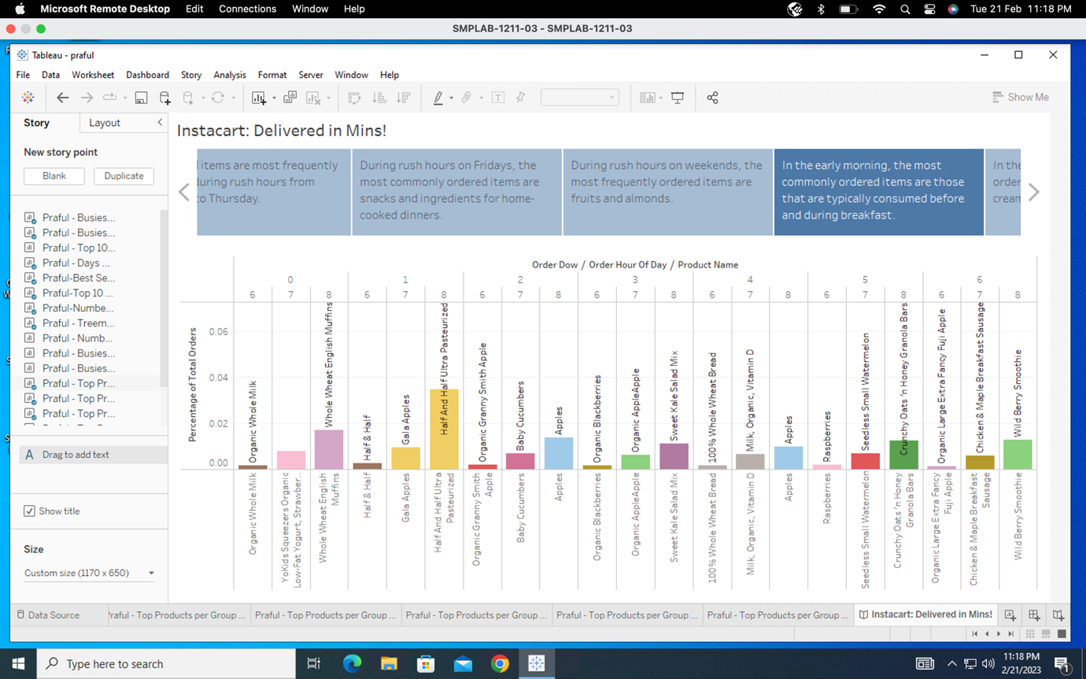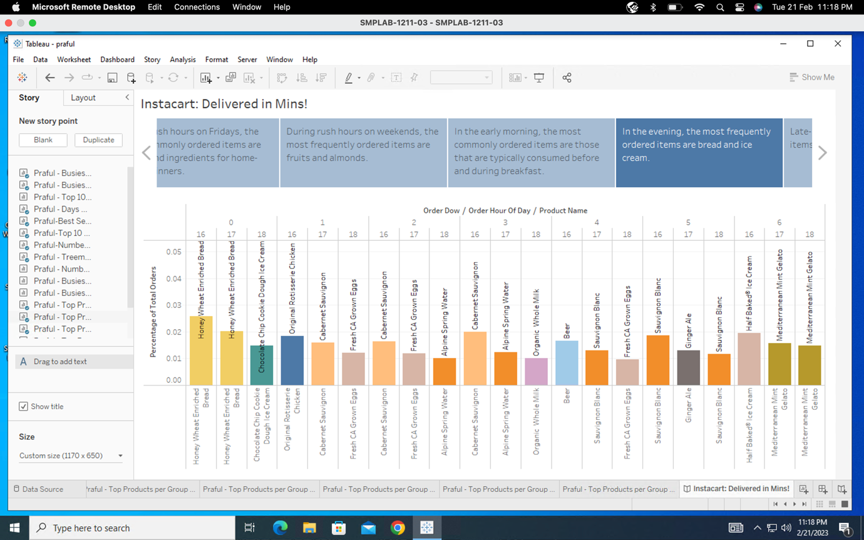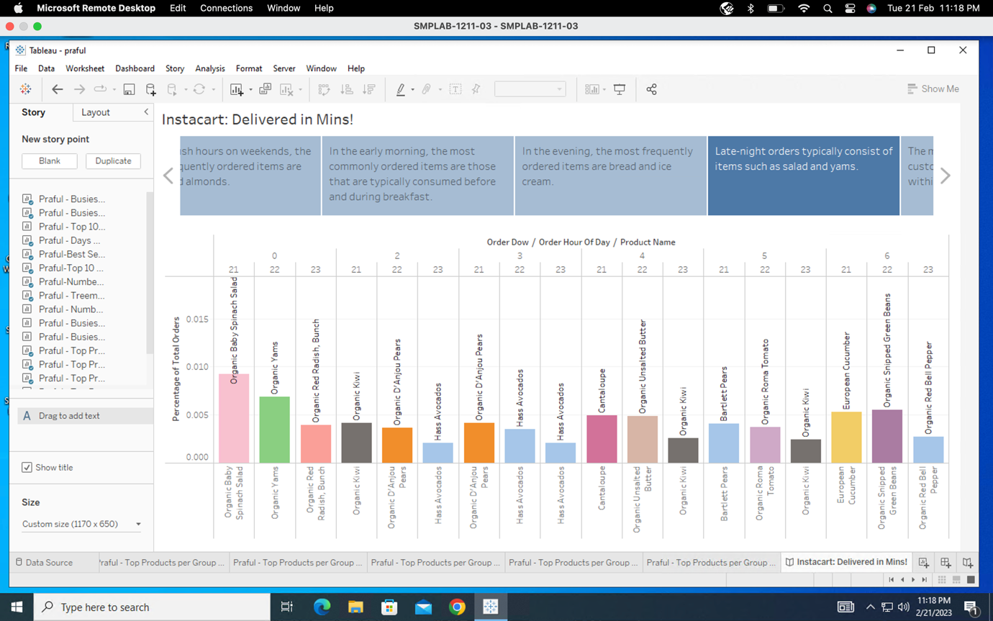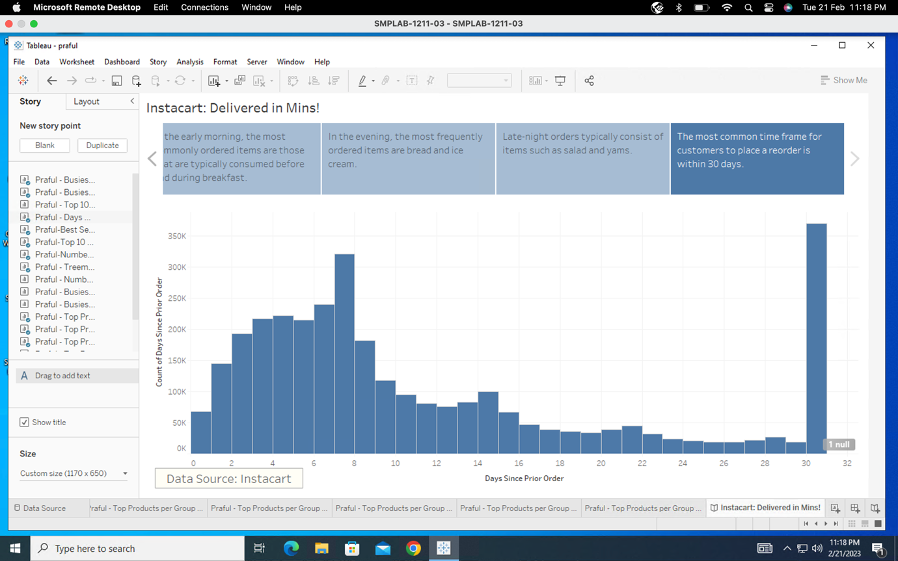

**Section 7: Formatting the Story**